Student Performance Project Workflow
  - EduPredict | Updated 12 October 2026
This workflow shows the completed path from problem framing to final evaluation and staff recommendations. Both feature scenarios share the same data split. Training cross-validation compares models; final evaluation uses the frozen selected pipelines on the held-out rows. No test-based tuning or threshold selection is performed.
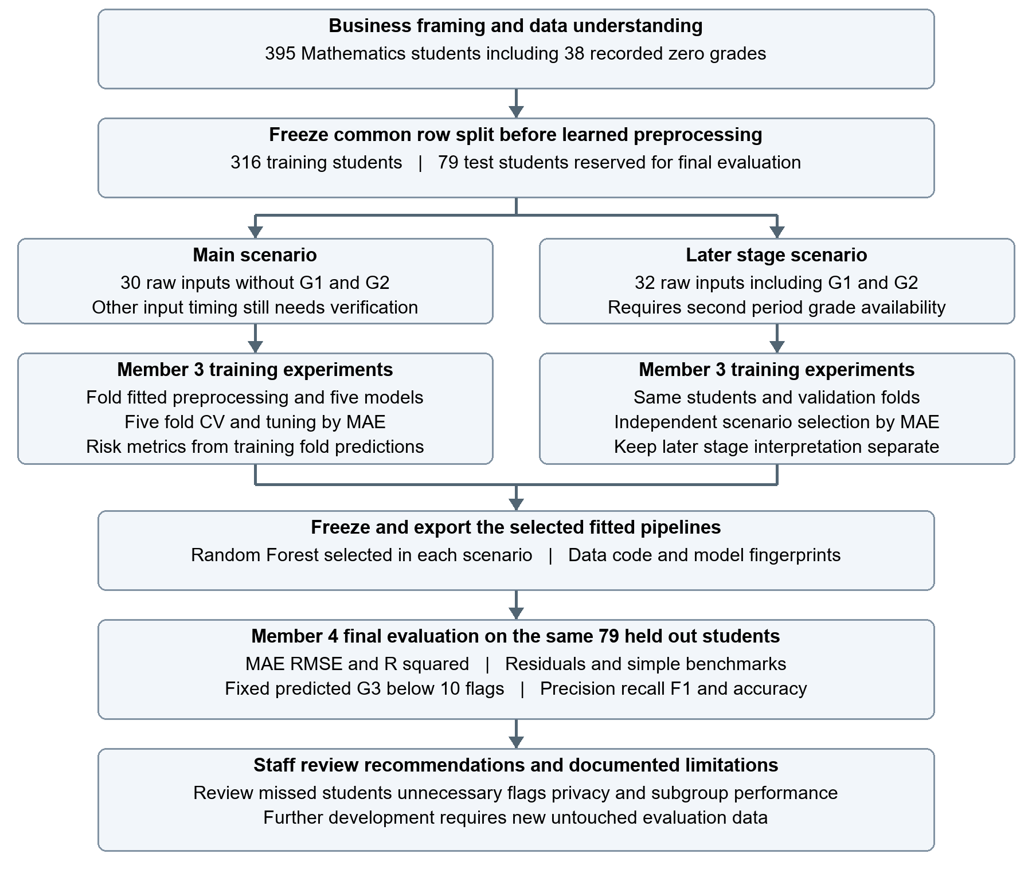
Figure 1 Project flow and the training to evaluation handoff

Completed stages and evidence
Stage | Action and evidence
1 Framing and data | Define G3 regression, student-level analysis and the potentially at-risk rule. Notebook 01 explores the Mathematics data; the dictionary defines raw fields. Keep all 395 records including 38 zeros.
2 Split and preprocessing | Notebook 02 explains the 316/79 split and transformations. src/preprocessing.py supplies reusable binary encoding, one-hot encoding, original/log absences and optional scaling/prior grades. Learned steps stay inside training folds.
3 Model experiments | Notebooks 03a–03e own initial and tuned versions of Linear Regression, Ridge, Decision Tree, Random Forest and Gradient Boosting. Use five shared shuffled training folds; mean/median baselines provide references.
4 Training risk metrics | src/model_utils.py creates one out-of-fold prediction per training student per model configuration. Derive grade-10 flags and report accuracy, precision, recall, F1, specificity and confusion counts. These reuse selection folds and may be optimistic.
5 Selection and export | Notebook 03 selects by mean CV MAE separately per scenario; both winners are Random Forest. Save complete fitted pipelines; selected-model metadata records exact feature/row lists, package versions and hashes. No held-out metrics influence this choice.
6 Final evaluation | Notebook 04 checks artifacts and predicts the same 79 test records with both frozen models. Compare regression baselines, G2 unchanged, residuals, fixed-threshold flags and descriptive sex/school group checks. No refitting or retuning.
7 Recommendations | Keep findings, metrics, predictions and risk cases inside Notebook 04. Staff review flags alongside other evidence; document limits and propose prospective evaluation on a new cohort.

Team handoff
Member 3 owns ML-ready data through the selected regression models: baselines, training, cross-validation, tuning, comparison and modelling decisions. The handoff includes fitted pipelines, scenario metadata and results displayed in the notebooks. Member 4 owns model through decision and recommendation: final metrics, residuals, risk errors, supportive recommendations and limitations. The per-model risk sections complement Member 3’s training comparison; the final test interpretation belongs to Member 4.

Results at the final evaluation stage
The main forest’s test MAE is 3.095 and its grade-10 rule misses 17 of 27 at-risk students. The later-stage forest’s MAE is 1.170; it misses none but generates 10 false positives. G2 unchanged has MAE 1.000, and G2 < 10 misses one student with six false positives. These results support a cautious review of the need for model complexity and the cost of missed support versus additional reviews.

Boundaries that remain in force
- Timing: G1/G2 requires later-stage availability. Define a prediction date and verify all other inputs, particularly absences, before claiming early use.
- Evaluation: the 79-row holdout has now been inspected. Do not use its results for new model, transformation or threshold selection; use new untouched data for further development.
- Exploration: Notebook 01 examined the full dataset before splitting. The holdout was reserved from model fitting and tuning but was not fully blind to EDA.
- Interpretation: zero-grade causes and failures-code semantics remain uncertain. Preserve these caveats rather than infer dropout or causal interventions.
- Responsible use: predictions support human review. Missing a flag must not deny assistance; privacy, subgroup performance and school workload require further validation.

Reproducing the workflow
Run model notebooks 03a–03e in any order, including their final risk-metric sections, then run Notebook 03 to validate and compare records. Notebook 04 reproduces the evaluation of the selected models. A code or data change requires fresh training artifacts; it does not restore the already-inspected holdout to unseen status.
Full run instructions: notebooks/README.md and docs/model_experiment_workflow.md. Training model and risk comparisons remain in Notebooks 03a–03e and 03. Final evaluation, plots and recommendations remain in Notebook 04. No result files are exported to docs.

